**6.8 Graphing Radical Functions**.  
Objective: To graph square root and other radical functions

A square root function is the inverse of a quadratic function that has a limited domain.

**Note:** Remember the importance of “a” on our graphs

If a is negative 🡪 reflects over x-axis

If a is >0 🡪 stretches

If a is between 0 and 1 🡪 shrink

Remember the importance of “h” on our graphs

Shifts graph horizontally (think opposite)

Remember the importance of “k” on our graphs

Shifts graph vertically

I think it is easiest to first graph the “Parent Graph” of a square root or cube root (below) and then translating it horizontally/vertically.

**Square Root;** 

Graph starts at the origin and passes through point (1, a)

* Remember: Domain for  is x ≥ 0

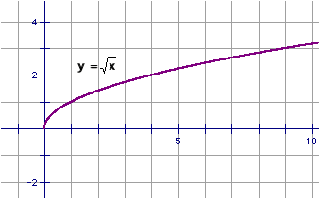

**Cube Root;** 

Graph passes through the origin and the points (-1, -a) and (1, a)

* Domain is all real numbers, because 3 is an odd root

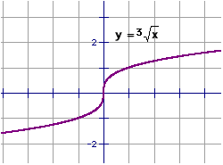

**Graphs of Radical Functions**;

To graphor, follow these steps:

1. Sketch the graph of or
2. Shift the graph h units horizontally and k units vertically

*Example*: Graph 

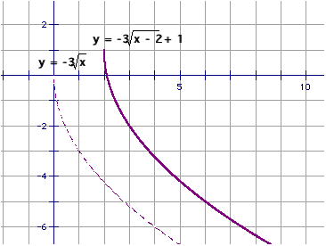

**Domain**: the set of input values (all possible x values)

**Range**: the set of output values (all y values yielded from the domain)

*Example*: 

Domain:

Range:

*Examples:*

*Describe how to obtain the graph g from the graph f*



*Graph the function. Then state the domain and range.*



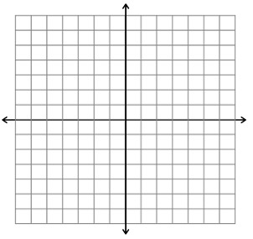





**HMWK: page 418 #1-2, 5, 7, 13, 19, 25, 29**